After completing this lab, you should be able to:
- Verify the Verilog Gate-Level netlist matches the RTL-Level simulation by compiling and simulating the Gate-Level netlist with the RTL-level testbench without enabling any optimization switch and without timing using VCS
- Demonstrate the same Verilog Gate-Level netlist when compiled and simulated with the +rad optimization switch exhibit an improvement in simulation performance
- Verify an existing Verilog Gate-Level netlist with timing matches the RTL-Level simulation

Fast Gate-Level Verification


45 minutes
Unit 7
Learning Objectives
7

Getting Started
You will use a FIFO for this lab.
Here's a preview:
- Verify that the Verilog RTL code passes verification
- Using the same testbench, verify that a gate-level netlist generated from the same source code also simulates correctly.
- Compile and simulate the same gate-level netlist with optimization options and observe an increase in simulation performance.
- Add back-annotation system task to source code
- Compile and simulate SDF back-annotated gate-level netlist and observe that this also simulates correctly.

Figure 7-1: Flow Diagram of Lab Exercise
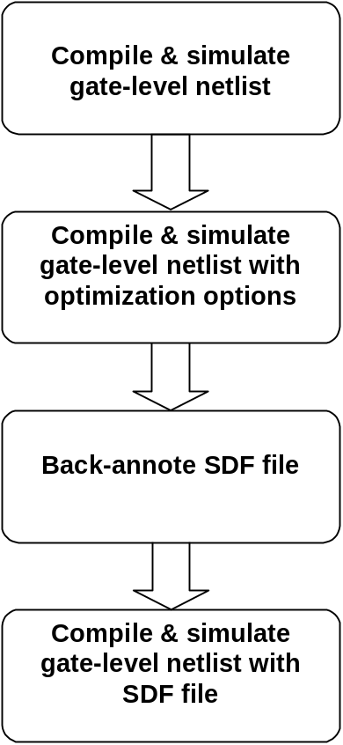

Gate-Level Simulation
- Examine Gate-level Verilog Files
Go into the lab8 directory.
- shell> cd lab7
Take a look at the gate-level Verilog files created by Design Compiler.
- shell> more fifo32X8_gate.v
You should see the gate cells instantiated in all the _gate.v files. These were created through synthesis with Design Compiler with the vendor’s technology libraries.
In order to simulate the gate-level Verilog files, you must also have the vendor’s Verilog simulation files. In our case, this simulation file is located in vcs/lib/vendor_lib under the file name core.v.
Take a look at core.v.
- shell> more ../lib/vendor_lib/core.v
As you scan through the core.v file, you will see both UDP (User Defined Primitives), functional modules, and gate-level cell modules.
Where are the timing information defined?
- Compile and Simulate the RTL Netlist
Let’s verify that the RTL netlist works.
Here’s the content of fifo.f:
fifo32X8tb.v
fifo_cntrl.v
fifo32X8.v
fifo_mem.v
ram16X8.v
-P ../lib/fileio2.0/fileio.tab
Compile and simulate the RTL code.
- shell> vcs –f fifo.f fileio.o –R
- Record CPU time & Data structure size
CPU time:
Data structure size:
- Compile and Simulate the Gate-level Netlist
Let’s verify that this gate-level netlist works.
Here’s the content of fifo_gate.f:
fifo32X8tb.v
fifo32X8_gate.v
-P ../lib/fileio2.0/fileio.tab
Notice that all the RTL codes are replaced by the single fifo32X8_gate.v gate-level netlist.
Compile and simulate the Gate-level netlist without SDF backannotation
- shell> vcs –f fifo_gate.f fileio.o –R
- Record CPU time & Data structure size
CPU time:
Data structure size:
This is a integrity test to verify that the gate-level netlist does perform the operation in the same way that the RTL code did. Notice that the same testbench is used for both the RTL and gate-level verification.
But, this is not the ideal way to perform the gate-level to RTL confidence test. A better way may be to use a formal verification tool like Formality,
If you really want to use VCS to check the functionality of the gate-level netlist, use the following compile-time options.
- Compile and Simulate with Optimization Options
- shell> vcs –f fifo_gate.f fileio.o –R +rad +nospecify
- Record CPU time & Data structure size
CPU time:
Data structure size:
Notice how much faster the verification is?
- Back-Annotate SDF File
Let’s back-annotate the SDF file information for simulation with timing.
The only thing that you will need to do is to add the $sdf_annotate system task into the testbench. (Looks for the reserved space for this code)
- Insert the following code in the fifo32X8tb.v testbench as follows:
initial
begin
$sdf_annotate(“fifo32X8.sdf”, fifo);
end
- Simulate without Timing Check
If you are simulating your design with timing just to make sure that circuit delays does not introduce errors and you are using a separate timing verification tool, then, you should use the following compile-time options to get the best performance:
- shell> vcs –f fifo_gate.f fileio.o –R +notimingcheck
- Record CPU time & Data structure size
CPU time:
Data structure size:
- Simulate with Full Timing Check
If you are simulating your design with full timing check then use the following compile-time options.
- shell> vcs –f fifo_gate.f fileio.o –R +neg_tchk
- Record CPU time & Data structure size
CPU time:
Data structure size:
Full timing verification will always take the longest time to run. Yet, it does not guarantee full timing verification. A better approach is to use timing verification tools for timing check and use VCS to verify circuit operations.

